FLORA & FAUNA :
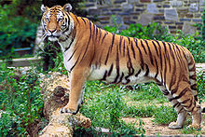
Owing to the varying altitude from the Himalayas to the coastal plains, the flora and fauna of the state is diverse. Forests make up 14% of the geographical area of West Bengal, which is lower than the national average of 23%. Protected forests cover 4% of the state area. Part of the world's largest mangrove forestSundarbans is located in southern West Bengal.
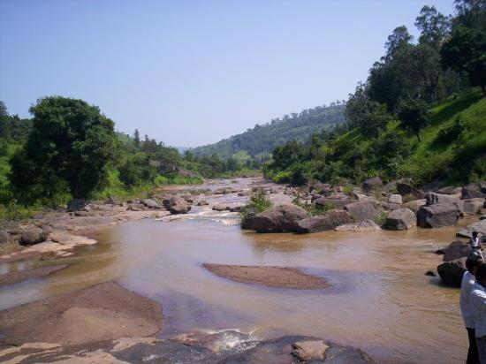
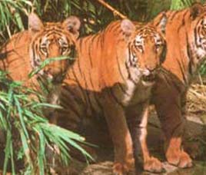
From a phytogeographic viewpoint, the southern part of West Bengal can be divided into two regions: the Gangetic plain and the littoral mangrove forests of the Sundarbans. The alluvial soil of the Gangetic plain compounded with favorable rainfall make this region especially fertile. Much of the vegetation of the western part of the state shares floristic similarities with the plants of the Chota Nagpur plateau in the adjoining state of Jharkhand. The predominant commercial tree species isShorea robusta, commonly known as Sal. The coastal region of Purba Medinipur exhibits coastal vegetation; the predominant tree is the Casuarina. The most valuable tree from the Sundarbans is the ubiquitous sundri (Heritiera fomes) from which the forest gets its name. Vegetation in northern West Bengal is dictated by elevation and precipitation. For example, the foothills of the Himalayas, the Dooars, are densely wooded with Sal and other trees of the tropical evergreen type. Above 1000 m, the forest type changes to subtropical. In Darjeeling, which is above 1500 m, common trees typifying the temperate forest are oaks, conifers, and rhododendrons.
The Sundarbans are noted for a reserve project conserving Bengal tigers. There are five national parks in the state — Sundarbans National Park, Buxa Tiger Reserve, Gorumara National Park,Neora Valley National Park and Singalila National Park. Wildlife includes the Indian rhinoceros, Indian elephants, deer, bison, leopards, gaur, and crocodiles. The state is also rich in bird life. Migratory birds come to the state during the winter. The high altitude forests like Singalila National Park shelter barking deer, red panda, chinkara, takin, serow, pangolin, minivet and Kalij pheasants. In addition to the Bengal tiger, the Sundarbans host many other endangered species like Gangetic dolphin, river terrapin, estuarine crocodile etc. The mangrove forest also acts as a natural fish nursery, supporting coastal fishes along the Bay of Bengal.

